Explore the different careers using the national careers service: https://nationalcareers.service.gov.uk/explore-careers

Year 7 Maths Topics | Careers that use this information and/skill | 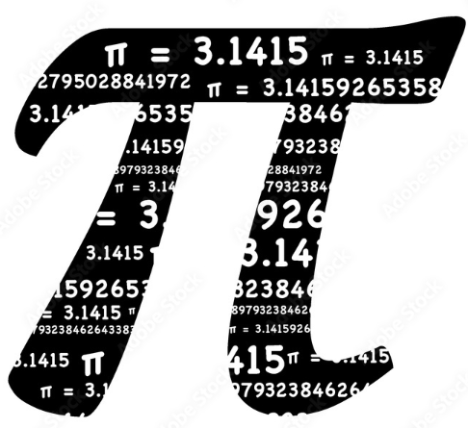 | 
Number Sense and Calculations | Retail Assistant (Calculates change and manages stock levels)  Primary School Teacher (Teaches foundational math concepts)  Financial Analyst (Analyses market trends and company finances) | BBC Bitesize Careers  National Careers Service
Expressions and Equations | Administrative Assistant (Uses spreadsheet formulas for data entry)  Paramedic (Calculates drug dosages using medical formulas)  Software Engineer (Writes algorithms and logic-based code) | MyPath - Maths: Why Bother?  iCould Careers
Measures | Baker or Chef (Accurately weighs and measures ingredients)  Nurse (Records patient measurements and fluid balances)  Civil Engineer (Requires high-precision measurements for infrastructure) | My Learning, My Future  Work Ready Lancashire
2D Shapes | Painter and Decorator (Plans tessellation and surface coverage)  Highway Maintenance Worker (Paints road markings and places signage)  Architect (Designs complex building layouts and floor plans) | National Careers Service  BBC Bitesize Careers
Perimeter and Area | Landscaper or Gardener (Calculates materials needed for turfing or fencing)  Police Officer (Secures and measures perimeters of crime scenes)  Town Planner (Zones large areas of land for city development) | iCould Careers  Work Ready Lancashire
Coordinates | Delivery Driver (Uses grid systems and GPS to navigate routes)  Army Soldier (Uses map reading and precise grid references)  Air Traffic Controller (Tracks aircraft on radar coordinate systems) | MyPath - Maths: Why Bother?  BBC Bitesize Careers
Factors, Multiples and Primes | Warehouse Operative (Packs items into boxes evenly for shipping)  Timetabling Officer (Schedules shifts for school or hospital staff)  Cyber Security Expert (Uses prime numbers to create secure encryption keys) | My Learning, My Future  National Careers Service
Fractions | Carpenter (Measures wood and splits lengths into equal parts)  Social Worker (Budgets and allocates community resources)  Pharmacologist (Formulates precise chemical compositions for drugs) | BBC Bitesize Careers  iCould Careers
Brackets | Bookkeeper (Follows basic sequences for data entry and invoicing)  Customs Officer (Calculates tariffs and duties in a specific order)  Data Scientist (Creates complex statistical models and equations) | MyPath - Maths: Why Bother?  Work Ready Lancashire
Angles | Bricklayer (Ensures corners and walls are perfectly square/level)  Firefighter (Calculates ladder angles and water jet trajectories)  Aerospace Engineer (Designs aircraft wings and flight trajectories) | My Learning, My Future  iCould Careers
Handling Data & Statistical Diagrams | Market Research Interviewer (Collects and tallies basic survey data)  Local Government Administrator (Collates community feedback into charts)  Epidemiologist (Analyses patterns of disease spread in populations) | National Careers Service  BBC Bitesize Careers
Proportion | Hairdresser (Mixes hair dye using specific ratios)  NHS Dietitian (Calculates dietary requirements based on body mass)  Chemical Engineer (Scales up chemical reactions for mass production) | MyPath - Maths: Why Bother?  Work Ready Lancashire
Fractions, Decimals and Percentages | Sales Assistant (Calculates discounts, VAT, and sale prices)  HMRC Tax Inspector (Calculates tax brackets and deductions)  Investment Banker (Analyses interest rates and financial yields) | My Learning, My Future  iCould Careers
Probability | Quality Control Inspector (Spot-checks random samples on a production line)  Met Office Meteorologist (Calculates the percentage chance of weather events)  Actuary (Calculates complex financial risks for insurance companies) | BBC Bitesize Careers  National Careers Service

